Mu Alpha Theta
Application
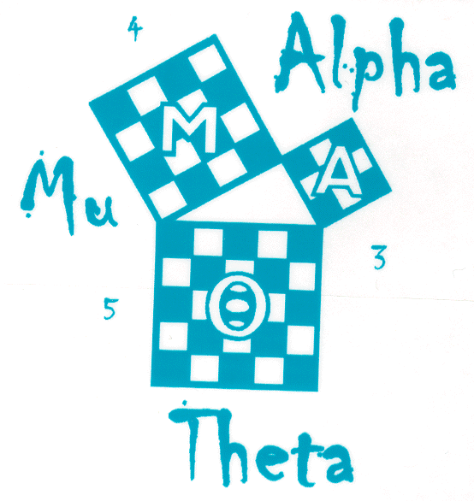
National Mathematics Honors Society
Wicomico High School Chapter

Dear Student,

We are excited to see that you are considering to join our awesome community!

For your application to be considered, you must complete and submit it in its entirety and promptly. This application is due at the November meeting. Late applications will not be considered, so please try your best to submit your application on time. If it is necessary to turn in your application earlier than its due date, you must submit the applications to Mrs. Vickers in room E-08 or to Mrs. Hooker in room A-21.

If you are accepted, you will be notified through a letter which will include further instructions regarding membership so please pay close attention to that letter. Remember that you must attend the induction ceremony and perform the ceremonial procedure in order to become the member. Your family members are also invited to attend.

We look forward to receiving your application!

Best regards,

Mrs. Vickers and Mrs. Hooker
Sponsors of Mu Alpha Theta

Wicomico High School Mu Alpha Theta Application Sheet
Please clearly print all fields. You must obtain your GPA and class grades from guidance.
Name (print exactly as you want it on your certificate):

_________________________________________ Year of Graduation: ____________________

Email: _______________________________________________________________________

Current Math Class: _________________ Current Math Teacher: _________________

Unweighted overall GPA: ____ / 4.0
Math classes taken and final grade:
Class Year Final Grade
Algebra 1 ____________ _______
Algebra 2 ____________ _______
Geometry ____________ _______
Trig/Pre Cal ____________ _______
Cal 1 ____________ _______
Cal 2 ____________ _______
Stats (honors or AP) _____________ _______

Guidance Signature: ____________________

You must ask for recommendations from two teachers, one of whom must be a mathematics teacher. The recommendation forms were distributed along with this application at the interest meeting, and additional forms may be obtained from Mrs. Hooker in room A-21 or Mrs. Vickers in room E-08. You are not permitted to access the completed recommendation form; it must be directly received by Mrs. Hooker or Mrs. Vickers from the teacher to whom you request your recommendation. Do NOT review or bring the completed recommendation yourself.

As the member of Mu Alpha Theta, you will be equipped with many responsibilities which were explained at the interest meeting. These duties include but not limited to:

- Having your permanent records residing at Wicomico High School
- Demonstrating of honorable attitude and behavior at all times
- Having no recorded suspension (dealt with on a case by case bases)
- Completing at least 2 college track math classes
- Attending the meetings regularly
- Maintaining average unweighted overall GPA of at least 2.0 on a 4.0 scale
- Maintaining average unweighted mathematical GPA of at least 3.0 on a 4.0 scale
- Paying $10.00 as a lifetime membership fee
- Being enrolled in at least one mathematics course each high school year
- Committing an hour of service every month

By signing below, I certify that I have completed this form independently to the best of my knowledge without plagiarism and that I am well aware of the responsibilities that I shall undertake as a member.

Signature: _______________________________________________ Date: _______________

