Due the 1st day of School! You MUST SHOW WORK to receive credit, NO WORK, NO CREDIT! Answers on this page, work on a separate sheet.
Part I: Laws of Exponents
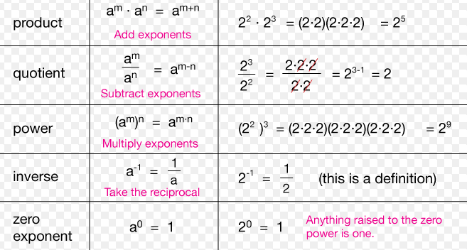
Simplify the expression using the laws of exponents. There should be no negative exponents when completely simplified.
- $x^{5}∙x^{2}$ 2. $y^{3}∙y∙y^{4}$ 3. $2b^{4}∙3b^{-4}$

- $a^{10}∙a^{2}∙a^{-6}$ 5. $\frac{x^{5}}{x^{2}}$ 6. $\frac{c^{4}}{c^{8}}$

7. $\frac{5x^{4}}{x^{9}}$ 8. $\frac{2c^{5}}{4c^{3}}$ 9. $\frac{b^{3}∙b^{4}}{b^{2}}$

10. ${\left(z^{5}\right)}^{5}$ 11. ${\left(a^{7}\right)}^{2}$ 12. ${\left(m^{-3}\right)}^{-8}$

Distributive Property of Exponents:
Property | Example
$${\left(xy\right)}^{a}=x^{a}y^{a}$$ | $${\left(x^{2}y^{3}\right)}^{2}={\left(x^{2}\right)}^{2}{\left(y^{3}\right)}^{2}$$  $=x^{2∙2}y^{3∙2}$  $=x^{4}y^{6}$
$${\left(\frac{x}{y}\right)}^{a}=\frac{x^{a}}{y^{a}}$$ | ${\left(\frac{x^{2a}}{y^{3b}}\right)}^{3}=\frac{{\left(x^{2a}\right)}^{3}}{{\left(y^{3b}\right)}^{3}}$  $=\frac{x^{2a∙3}}{y^{3b∙3}}$  $=\frac{x^{6a}}{y^{9b}}$

13. ${\left(3x^{2}\right)}^{4}$ 14. ${\left(2ab\right)}^{5}$ 15. ${\left(x^{2}y^{4}m^{3}\right)}^{8}$

16. ${\left(2x^{3}y^{6}\right)}^{6}$ 17. $p^{2}∙{\left(p^{5}\right)}^{2}$ 18. ${\left(m^{7}\right)}^{4}∙m^{3}$

19. ${\left(\frac{a^{2}}{b^{3}}\right)}^{4}$ 20. ${\left(\frac{2m^{3}}{3}\right)}^{3}$ 21. ${\left(\frac{3x^{3}}{4y^{4}}\right)}^{2}$

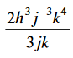
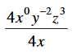
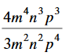
Putting it all together:
23. 24. 25.

Part II: Factor out the Greatest Common Factor
Factor out the GCF:

Part III: Factor by Grouping
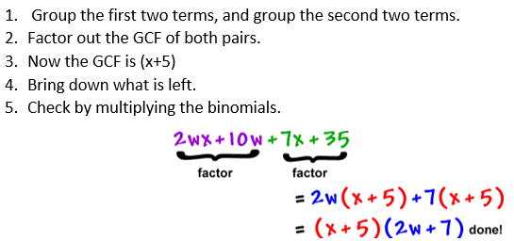
Factor the following by grouping:

Part III: Factor a Trinomial (YOU MUST SHOW WORK!)
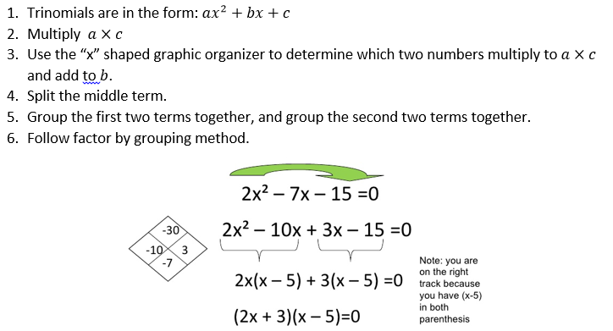

Part IV: Factor a Difference of Squares
